The Derry Model

About Derry, Northern Ireland:

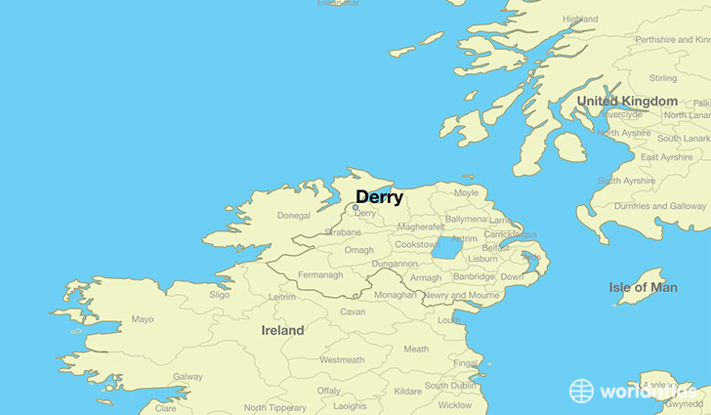
The city of Derry, Northern Ireland was horribly affected by the Troubles, many regarding it as the epicentre of the conflict with origins in the Battle of the Bogside. Derry has had a tumultuous history of sectarian tension and violence for centuries. The Apprentice Boys of Derry – a Protestant fraternity based in Derry paraded annually to commemorate the 1689 Siege of Derry in which Protestant supporters of William III of England withstood the Catholic
supporters of James II of England for 105 days. Many Catholics saw the parade as divisive and boastful. This eventually resulted in widespread rioting in the City compounded by ideas of political marginalisation and poor work and living conditions. This spurred 40 years of conflict in Northern Ireland including one of the Troubles’ most notorious events, ‘Bloody Sunday’ where 31 civil rights protestors were shot by British Army Officers.
https://www.worldatlas.com/eu/gb/nir/where-is-derry.html
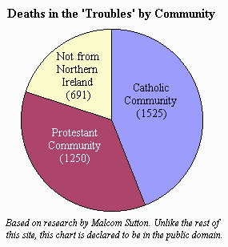
Regular riots, bombs, shootings took place across the City. The protestant Waterside and Catholic Cityside constantly saw conflict against each other as well as alongside or against the British soldiers, police and paramilitary organisations. This divide remains to this day, although tensions are easing since the 1998 Good Friday Agreement and tireless work done by local stakeholders such as the Bloody Sunday Trust and Derry Model. Through the work of the Bloody Sunday Trust and local key cross-community stakeholders the “Derry Model” was born out of an agreement reached over these local parades, which successfully brought together the loyal order of the Apprentice Boys of Derry, local residents and representatives from the business community.

Demographics & Statistics:

- Multiple Deprivation- ranked 5th most deprived area in Northern Ireland out of 890 Super Output Areas.
- Income Deprivation- ranked 10th most deprived area in Northern Ireland out of 890 Super Output Areas.
http://www.wesleyjohnston.com/users/ireland/past/troubles/troubles_stats.html
- Health and Disability Deprivation- ranked 36th most deprived area in Northern Ireland out of 890 Super Output Areas
- Living Environment Deprivation- ranked 9th most deprived area in Northern Ireland out of 890 Super Output Areas
- Crime and Disorder Deprivation- ranked 10th most deprived area in Northern Ireland out of 890 Super Output Areas

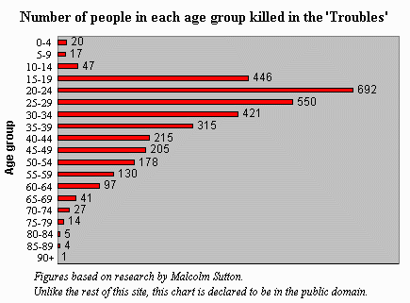

Current Political Situation:

After 1998 Good Friday Agreement was signed there was a general decline in political violence as a whole, many thought it would lead to economic growth. However, in Derry economic underdevelopment were perhaps a cause and not a consequence of the conflict – partially due to its geography. Official statistics reveal that five of the ten most deprived localities in Northern Ireland are located within the Derry and Strabane District Council area. Derry also has the fourth lowest life expectancy in the U.K. and tops the league tables for disability, morbidity and self-harm hospital admissions. The city also suffers with brain drain as many high achievers choose to receive high education elsewhere. The local economy also is in bad shape due to the legacy of sectarian regional policy and deindustrialisation. In a place of poverty and joblessness, many people are wooed by the offers of dissident republicanism.

Introduction to the project:

Given the aforementioned history of conflict in Derry and the fragility of political situation of post-conflict states exacerbated by poor socio-economic conditions, it is a huge success to bring together a community after the deep-rooted sectarian issues associated with the Apprentice Boys’ of Derry. Therefore, the ‘Derry Model’ is a method that can be applied in working towards peacebuilding and conflict resolution. Using the people of Derry to help others in divided and vulnerable societies by creating a conflict transformation and peace building project referred to as the ‘Derry Model.’

Details of the project:
The project aims to mirror and teach others nationally and internationally who struggle with conflict related and social justice issues to tap into the resources from protagonists in the conflict in Derry. These protagonists are best equipped to share the journey of reconciliation and peace building – offering a template for other divided societies to mirror. The use of the ‘Derry Model’ as a tried-and-tested method in mitigating violence and reconciliatory dialogue.

What is the Derry Model?
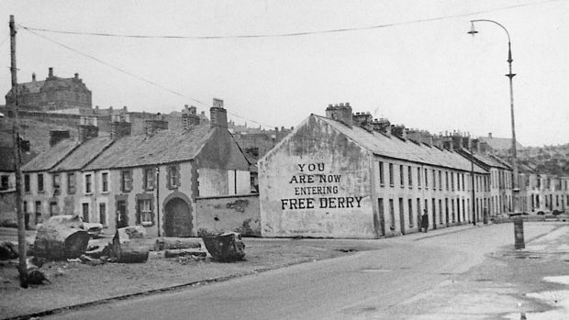
The Derry Model can be described specifically as the set of unique circumstances in Northern Ireland that led to a process of peace and reconciliation that eventually led to a power-sharing council in the North; a public apology by the former Prime Minister David Cameron and an all-round consensus of the importance of peace and reconciliation. Although the Derry Model is born out of unique circumstances in Northern Ireland, these circumstances highlight principles that can be applied to many conflicts. The principles of leadership and risk-taking amplified by the Derry Model can transcend language and borders, thus the Derry Model cannot be confined to Derry but has the potential to aid reconciliation and dialogue in many conflict areas.
https://www.irishtimes.com/news/ireland/irish-news/you-are-now-entering-free-derry-50-years-on-1.3747984

Why?

The promotion and maintenance of peace and security are central tenants of the United Nations agenda since its inception – usually by way of mediation, peacekeeping, peacebuilding, countering terrorism and disarmament. The ideals of justice and equality for all are important principles that are weaved throughout the UN agenda. However, in recent years, UN Secretary-General Antonio Guterres has been working to reform the UN’s approach to peace by introducing the prevention and sustaining peace agenda. In this agenda, there is a ‘prioritisation of the local’ which looks at how the international community can complement and support initiatives of local actors, rather than overt international mediation that can be sometimes be viewed as intrusive and imposing.

- Analyse drivers of peace, not conflict

- Marry the three pillars of the UN (development, security and human rights)

- Inclusivity among stakeholders

- Partnerships

- The need for education

Main points highlighted in the Secretary-General’s Sustaining Peace report

This fits in very well with the principles and aims of the Derry Model, which aims to use the protagonists from the conflict and tensions in Derry that unified under the banner of ‘not in my name’ to create a consensus of peace and reconciliation amongst their community. The Derry Model also understands that justice is not one-dimensional and can have various meanings for different people; thus, knowing that there is not just one sense of justice whilst the UN’s position on peace and security undergoes a reformation to incorporate more local actors and initiatives positions the Derry Model to be teachable, forward-thinking framework as well as applicable to various conflicts due to its multi-dimensional approach with local actors at the core of its success.

Now that we have established a link between the Derry Model and the UN mandate for peace and security, our rationale is as follows:

- To offer support to peace model that has been successful in mitigating violence

- To continue the reconciliation dialogue between the two communities

This, however, is not to say that there is still no community work to be done in Derry. Like the aforementioned UN report mentions that development, security and human rights are pillars that are inextricably linked. The aforementioned statistics and political situation also show how the lack of opportunities, poverty and deindustrialisation necessitate assessing progress through the lens of development. The summer of 2018 saw a return to rioting and vandalism, which was met with community leaders, political parties and churches coming together and rallying in opposition to it. Although this is a point of hope that the consensus of peace in Derry is still very much alive, it also highlights just how fragile the political situation of areas with a history of conflict can be. Therefore, to truly build and promote peace there needs to be a holistic approach(es) that involve inclusive development, strong human rights and peace and security.

A brief published by the International Peace Institute has pointed out just what sustaining peace looks like as a practical policy proposal especially through the lens of development and human rights.

“Peace, unlike law and security, cannot be enforced from the top, but must be woven into society from within and from below by fostering partnerships and incentives to maintain it. Dialogue among individuals, groups, and social sectors, as well as between the government and its citizens, is key to the success of the sustaining peace enterprise; so is enlightened, inclusive leadership at all levels of society.”
‘Sustaining Peace: What Does it Mean in Practice?’ By Youssef Mahmoud and Anupah Makoond

The above quote shows the importance of keeping the consensus of peace through dialogue and incentives. This would mean that keeping tabs on and assessing the ongoing progress in Derry is of utmost importance in order to track and enhance peacebuilding and reconciliatory dialogue.

This would put into context our plans for the Derry Model and affirms our goals for its potential in Derry and beyond:

- To define “the Derry Model” and develop consensus on this as a brand

- To assess ongoing progress of the Derry Model

- To develop a clear and concise business plan, future objectives and strategies for the Derry Model, to include the Conflict Transformation Hub.

Budget & Objectives:

As it stands the net total for the Derry Model project is £10,800.

The objectives of the expenditure are as follows: conduct further studies, facilitate meetings with experts and support dissemination of good practices with promotional activities.

